Fishing village development role play

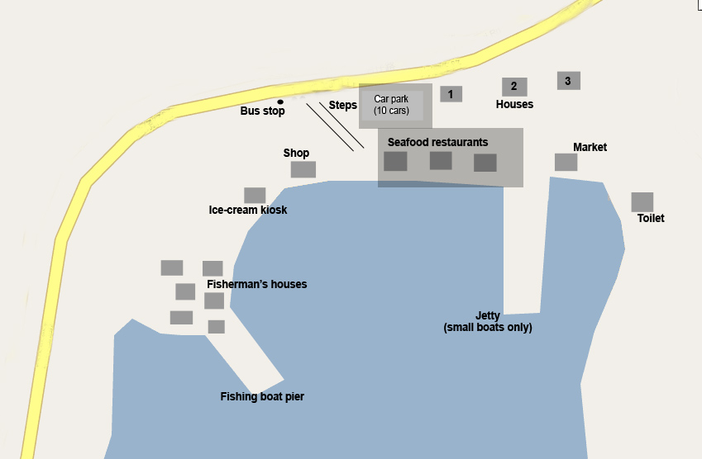

Situation
Sha Wan is a small fishing village in the New Territories. There are some traditional fishermen’s houses and a number of retirement homes. There is no ferry service and it is a long way to Central and Kowloon by public transport. Most families moved out decades ago.
There are very few visitors during the week but at weekends hikers and other tourists like to come for the beautiful views and the three excellent sea food restaurants. Junk parties sometimes stop here also.
Recently a development company, Billion Rich Developments (HK) Ltd., has become interested in developing the waterfront into a major leisure complex served by fast ferries from Central. They have offered the family that owns the restaurants and car park a lot of money. Their proposals are the subject of a meeting to be held in the village. You will take part in the meeting and play the role given to you.
Role 1 – Retired resident
You live in house No 1. You moved there from North Point three years ago when you retired. You have a lovely sea view and enjoy the peace and quiet in this area. You saved up for thirty years to buy this house.
Decide on your attitude to the proposals and brainstorm points to support your position.

Role 2 – Landlord
You are from a local family of fishermen and farmers. Your family has owned the land that the sea food restaurants and the car park are built on for hundreds of years. You have had an offer of HK$ 20 million from Billion Rich Development (HK) Ltd. They want to buy your land and develop this part of the village.
Decide on your attitude to the proposals and brainstorm points to support your position.

Role 3 – Billion Rich Development (HK) Ltd.
You are a major land developer that specializes in mass leisure development. You see enormous potential in this site. Your main interest is in mass market tourism – low cost, high volume.
Decide what your development will be and brainstorm points to support your position.

Role 5 – Representative of Green Heritage Hong Kong, a conservation group which supports both preserving the environment and supporting traditional villages and lifestyles.
Decide on your attitude to the proposals and brainstorm points to support your position.

