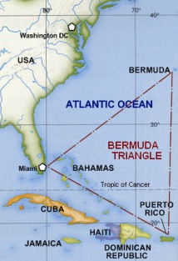 | 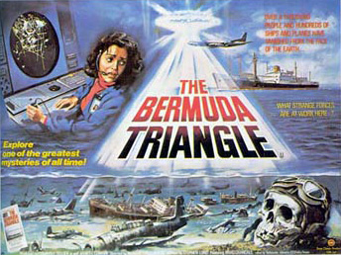 | 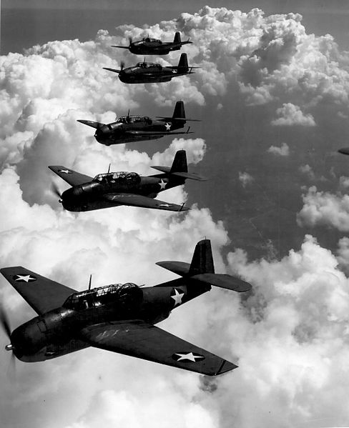
 | 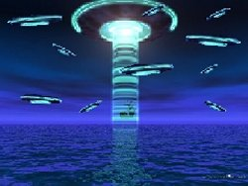

What do you know about the Bermuda Triangle?
- Where and what is it?
- Why is it called the Bermuda Triangle?
- What is supposed to have happened there?
- How would you classify a book or article on this topic – i.e. under what sort of headings would you put it? fiction, popular science etc.
- What other similar topics are you aware of?
- How much do you believe in this sort of thing? – What evidence do you have to support your view?

