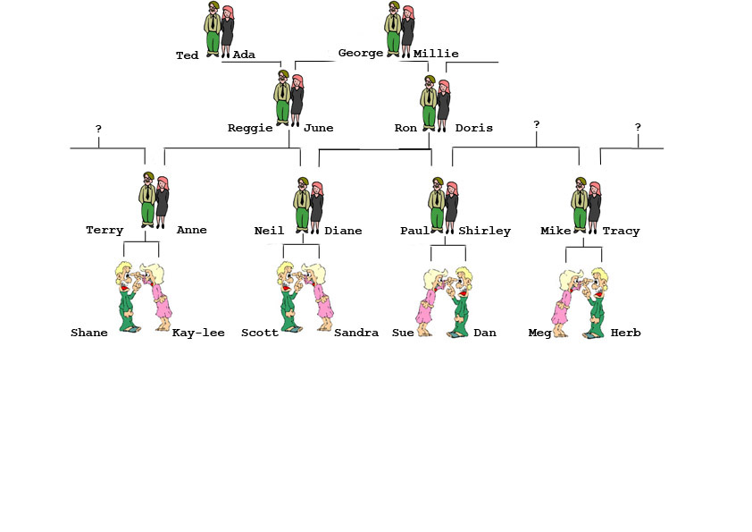
Family relationships

Shane is Kay-Lee’s ______________
Kay-Lee is Shane’s ________________
Terry is Shane and Kay-Lee’s __________ , and Anne is their __________ .
Anne is Terry’s ______________.

Neil is Anne’s _______________.
Scott and Sandra are Neil’s _________________
Neil is Shane and Kay-Lee’s _____________.
Shane is Neil’s ______________.
Kay-Lee is Neil’s ___________ .
Diane is Shane and Kay-Lee’s ___________ .
Scott and Sandra are Shane and Kay-Lee’s ______________.

Neil is Terry’s _____________.
Anne is Diane’s ______________.
Reggie is Anne’s ____________ .
Reggie is Terry’s _________________

Reggie and June are Shane and Kay-Lee’s _____________.
Shane and Kay-Lee are Reggie and June’s ________________.

Ted and Ada are Shane and Kay-Lee’s ________________
Ron is Shane and Kay-Lee’s _______________ .
Doris is Shane and Kay-Lee’s

